**NAME:** totalo muzammil

**REGISTER NUMBER:** 7139211040555

**NAAN MUDHALVAN ID:** au713921104055

**EMAIL ID:** tmuzammil55@gmail.com

**TITLE: COVID-19 VACCINES ANALYSIS**

**PROJECT DESCRIPTION:**

Conduct an in-depth analysis of Covid-19 vaccine data, including efficacy, distribution, and adverse effects, to provide insights that aid policymakers and health organizations in optimizing vaccine deployment strategies

**PROBLEM OVERVIEW:**

**Phase 1:** Empathize (Understand the Problem and Stakeholders)

Identify Stakeholders: Begin by identifying the key stakeholders involved, such as policymakers, healthcare providers, researchers, and the public.

**User Research**: Conduct interviews, surveys, and data collection to understand the unique challenges, concerns, and objectives of each stakeholder group. This may include collecting data on vaccine efficacy, distribution, and adverse effects.

**User Personas:** Create user personas that represent the diverse needs and perspectives of different stakeholders in the context of COVID-19 vaccine analysis.

**Phase 2:** Define (Identify the Problem Statement)

**Problem Definition**: Based on the insights gained from user research, define the specific problem statement. For example: "Optimize COVID-19 vaccine deployment strategies to ensure equitable access, address vaccine hesitancy, and maintain vaccine safety."

**Scope:** Clearly outline the scope of the analysis, specifying what aspects of efficacy, distribution, and adverse effects will be addressed.

**Phase 3:** Ideate (Generate Solutions)

Brainstorm Solutions: Facilitate brainstorming sessions to generate a wide range of innovative solutions to the defined problem. Involve stakeholders from different backgrounds to contribute their ideas.

**Idea Generation Techniques:** Use ideation techniques such as mind mapping, brainstorming workshops, and collaboration tools to generate creative ideas.

**Phase 4:** Prototype (Create Solutions)

**Develop Prototypes:** Create prototypes or mock-ups of the proposed solutions. These can include data analysis models, visualization tools, and communication strategies for vaccine analysis.

**Visualize Data:** Use data visualization tools to represent vaccine efficacy, distribution, and adverse effect data in an understandable and actionable manner.

**Phase 5:** Test (Gather Feedback)

**Pilot Testing:** Implement pilot projects or experiments to test the effectiveness of the proposed solutions. This may involve analyzing real-world data and conducting simulations.

**Gather Feedback:** Collect feedback from stakeholders, users, and experts to assess the impact of the prototypes and solutions.

**Iterate:** Based on the feedback received, refine and iterate the prototypes and solutions as needed.

**Phase 6:** Implement (Execute the Plan)

**Full Implementation:** Once a well-refined solution is identified and validated through testing, proceed to implement it on a broader scale. Collaborate with relevant stakeholders, such as policymakers and healthcare providers, to put the plan into action.

**Phase 7:** Evaluate (Assess Impact)

**Continuous Monitoring:** Continuously monitor and assess the impact of the implemented solution through data analysis and feedback from stakeholders.

**KPIs and Metrics:** Define key performance indicators (KPIs) and metrics to measure the success of the deployed strategies related to vaccine efficacy, distribution, and adverse effects.

**Phase 8:** Iterate (Refine and Improve)

**Iterative Process:** Design thinking is an iterative process. If the solution doesn't achieve the desired outcomes, return to the ideation phase and generate new ideas or adjustments.

**Continuous Improvement:** Continually refine and improve the strategies based on ongoing data and feedback. Adapt to the changing landscape of the COVID-19 pandemic.

**DATASET LINK:** <https://www.kaggle.com/datasets/gpreda/covid-world-vaccination-progress>

**DESCRIBE THE DATASET?**

Data is collected daily from Our World in Data GitHub repository for covid-19, merged and uploaded. Country level vaccination data is gathered and assembled in one single file. Then, this data file is merged with locations data file to include vaccination sources information. A second file, with manufacturers' information, is included. Detail About Columns:

**The data (country vaccinations) contains the following information:**

**• Country**- this is the country for which the vaccination information is provided;

**• Date -** date for the data entry for some of the dates we have only the daily vaccinations, for others, only the (cumulative) total

**• Total number of vaccinations -** this is the absolute number of total immunizations in the country

**• Total number of people vaccinated -** a person, depending on the immunization scheme, will receive one or more (typically 2) vaccines; at a certain moment, the number of vaccination might be larger than the number of people

**• Daily vaccinations -** for a certain data entry, the number of vaccination for that

**• Vaccines used in the country -** total number of vaccines used in the country

**DATA PREPROCESSING:**

**1. Data Collection:**

Collect data from reliable sources, such as health agencies, clinical trials, and real-world studies, regarding COVID-19 vaccines.

Ensure that the data is up-to-date and well-documented.

**2. Data Integration:**

Merge data from various sources, such as vaccine efficacy trials, distribution records, and adverse event reports, into a single dataset for comprehensive analysis.

Use data integration tools and techniques to handle data in different formats.

**3. Data Cleaning:**

Remove duplicates and inconsistencies from the dataset to prevent data contamination.

Handle missing values through imputation methods, like mean imputation or regression imputation.

Remove outliers that could skew the analysis.

**4. Data Transformation:**

Convert data into a consistent format and units. For example, ensure all vaccine efficacy percentages are represented in the same format.

Normalize or standardize variables if needed to make comparisons more straightforward.

**5. Feature Engineering:**

Create new features or variables that may be useful for the analysis. For example, you might calculate the average vaccine efficacy across different age groups.

Use domain knowledge to identify relevant features for the analysis.

**6. Data Aggregation:**

Aggregate data at different levels, such as by region, age group, or time period, to enable analysis at multiple scales.

Summarize data to obtain key statistics that can provide insights, such as the mean efficacy or distribution of adverse events.

**7. Data Splitting:**

Divide the dataset into training, validation, and testing sets to assess the performance of machine learning models and analyses.

Ensure that the data is randomly split to avoid bias.

**8. Handling Class Imbalance (Adverse Effects):**

In the case of adverse effects, there may be a class imbalance with more negative cases than positive cases. Techniques like oversampling or undersampling can be used to balance the classes.

Consider using synthetic data generation methods like SMOTE (Synthetic Minority Over-sampling Technique) to address class imbalances.

**9. Data Encoding:**

Convert categorical variables into numerical representations, such as one-hot encoding or label encoding, to enable machine learning algorithms to work with them.

Encode variables like vaccine brand, region, and age group.

**10. Time-Series Data Handling: -** If analyzing data over time, ensure time-series data is correctly formatted and sorted chronologically. - Consider aggregating data into time intervals or smoothing techniques to identify trends.

**11. Data Visualization:** - Create data visualizations to understand the distribution and relationships within the data. Visualizations can help identify patterns and outliers. - Use tools like histograms, box plots, scatter plots, and heatmaps to explore the data visually.

**12. Addressing Data Privacy and Ethics:** - Ensure that data handling complies with privacy and ethical guidelines. Anonymize and protect sensitive patient information. - Comply with data regulations like GDPR and HIPAA if applicable.

**13. Quality Control and Validation:** - Validate the preprocessed data to ensure its accuracy, reliability, and suitability for analysis. - Consider running data validation checks and audits to identify any inconsistencies.

**14. Documentation:** - Document all preprocessing steps and transformations, making it easier for other researchers and stakeholders to understand the data.

**MACHINE LEARNING ALGORITHMS:**

**Random Forest:**

Random Forest is an ensemble learning technique that combines multiple decision trees to make more accurate predictions. It is based on the idea that a group of weak learners (the decision trees) can come together to form a strong learner. Random Forest is a machine learning algorithm that falls under the category of ensemble learning methods. It is used for both classification and regression tasks and is known for its high accuracy and robustness. Here's a brief definition of the Random Forest algorithm:

**Decision Tree:**

A Decision Tree is a tree-like data structure that models decisions and their possible consequences. In the context of machine learning, a Decision Tree is used to make predictions by recursively splitting the dataset into subsets based on the values of input features. Each internal node of the tree represents a decision point, typically in the form of a feature test, and each leaf node represents a class label (in classification) or a numerical value (in regression). A Decision Tree is a supervised machine learning algorithm used for both classification and regression tasks. It is a graphical representation of a decision-making process based on features and their outcomes.

**Naive Bayes:**

Naive Bayes is a probabilistic classification algorithm that's based on Bayes' theorem. It is used for predicting the probability of a data point belonging to a particular class or category. The "naive" aspect of this algorithm is the assumption of feature independence, meaning it assumes that the presence of one feature in a class is unrelated to the presence of other features. The Naive Bayes algorithm is a probabilistic machine learning technique used for classification and text analysis. It's based on Bayes' theorem and is "naive" because it makes a simplifying assumption about the independence of features.

**Logistic Regression:**

Logistic Regression is a statistical and machine learning algorithm used for binary classification. It models the relationship between a binary dependent variable (the target or outcome variable) and one or more independent variables (predictors or features) by estimating the probability of the binary outcome. Logistic Regression is a popular statistical and machine learning algorithm used for binary classification tasks, which involve assigning data points to one of two classes. It models the probability that a given data point belongs to a particular class.

**Support Vector Machine (SVM):**

A Support Vector Machine (SVM) is a supervised machine learning algorithm that aims to find an optimal hyperplane in a high-dimensional feature space to separate data points into different classes. It is used for classification, regression, and outlier detection. A Support Vector Machine (SVM) is a powerful supervised machine learning algorithm used for both classification and regression tasks. SVMs are particularly effective when dealing with complex and high-dimensional datasets

**IMPORTING LIBRARY**

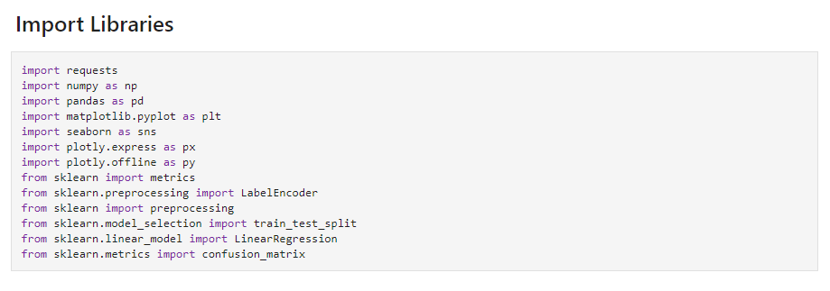

DATA PROCESSING

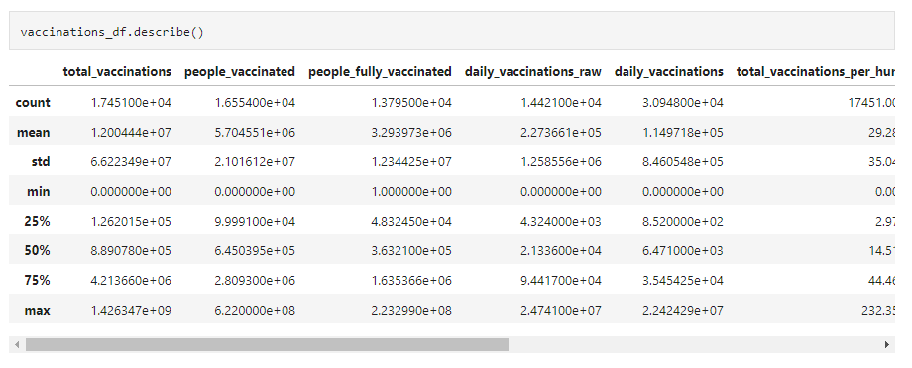

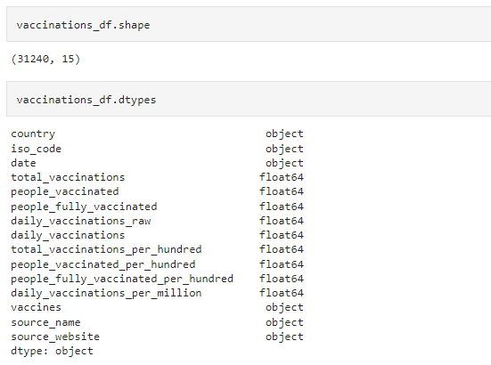



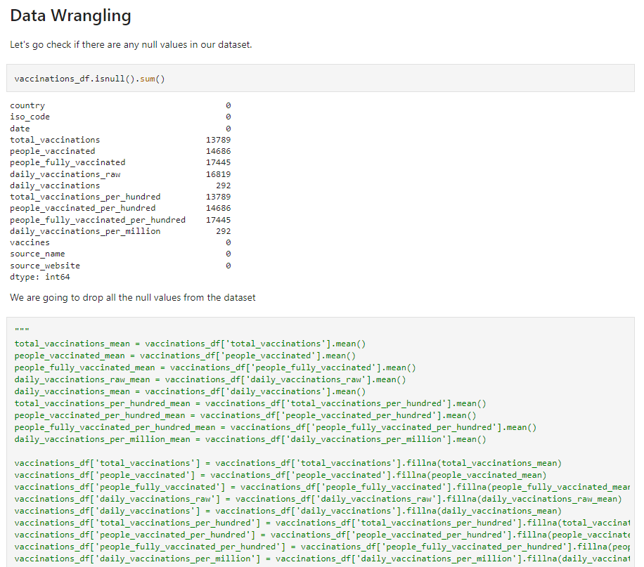

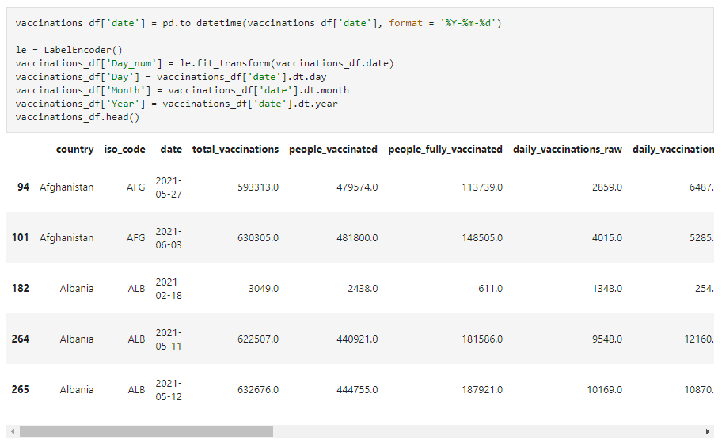

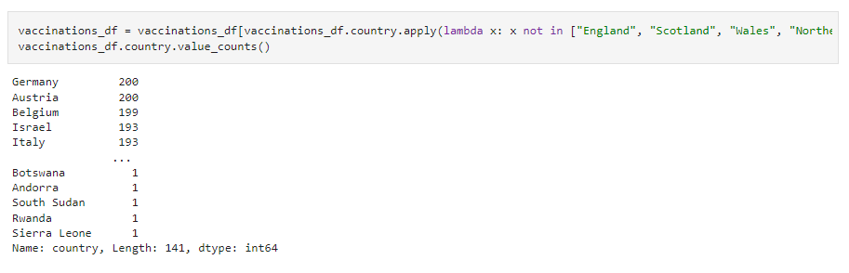

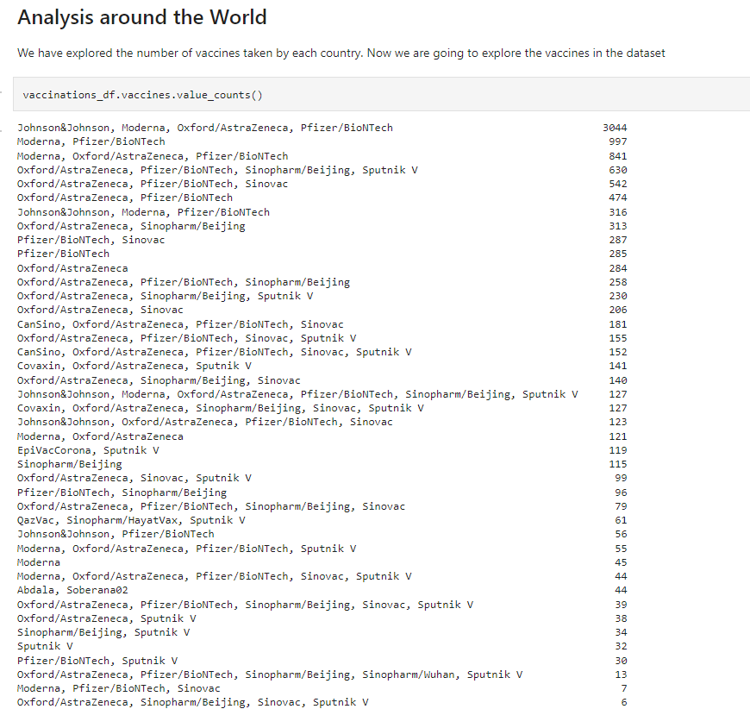

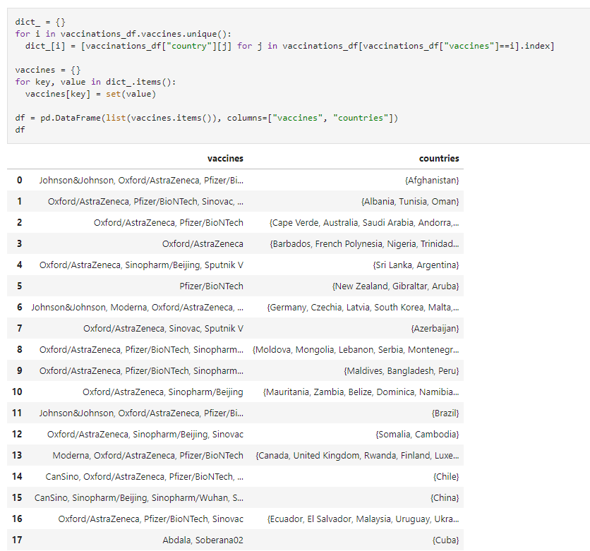

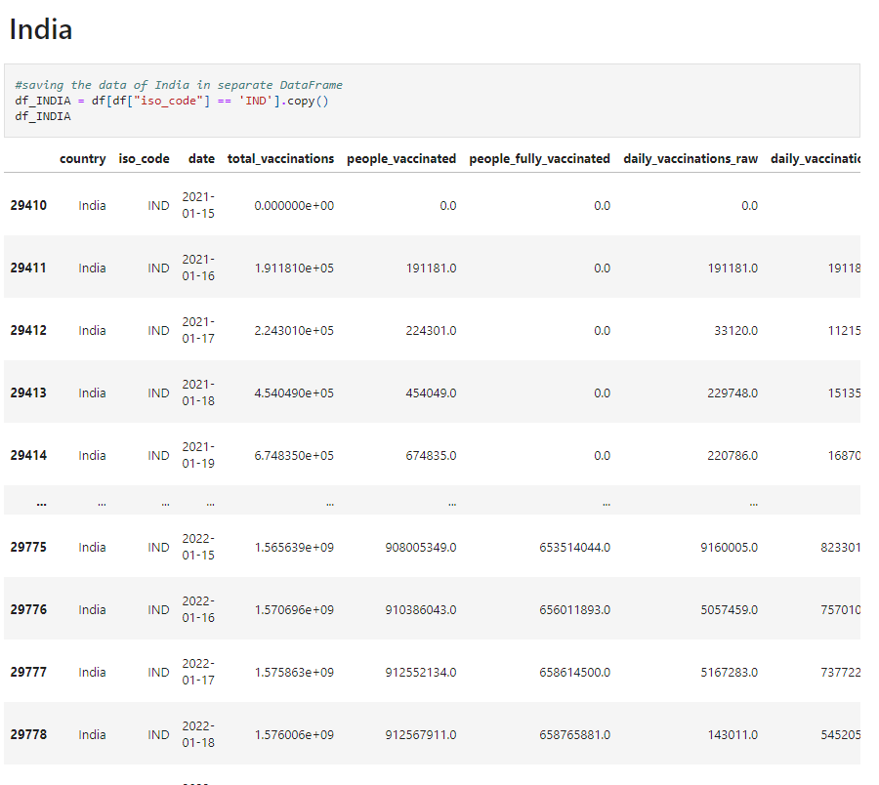

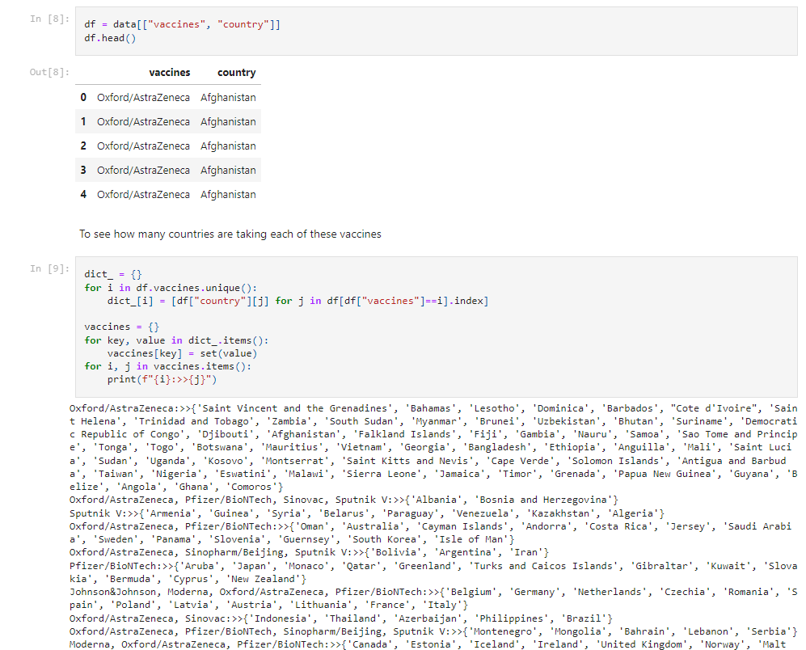

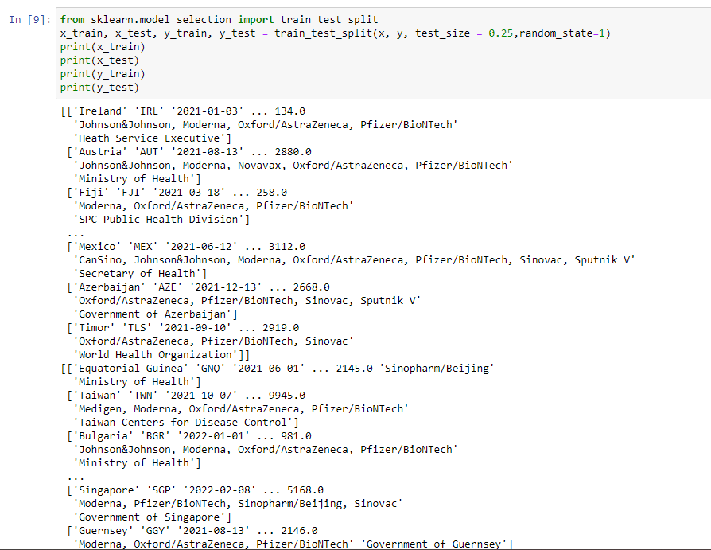

**VISUALIZING DATA:**

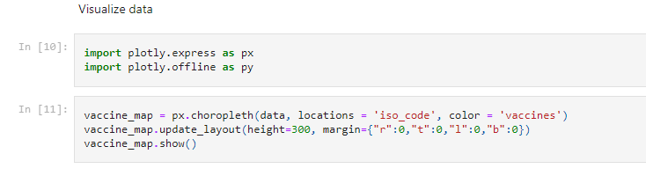

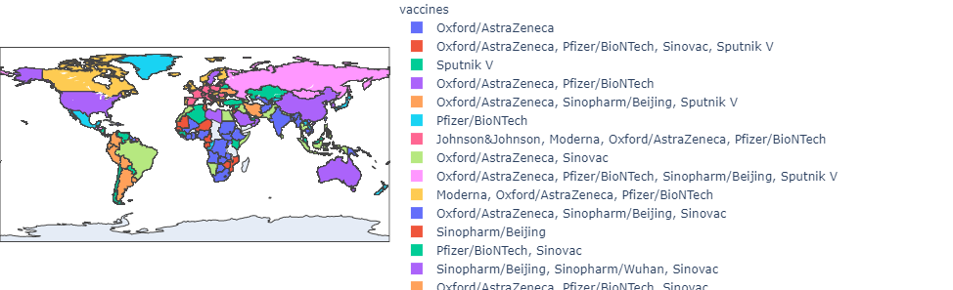

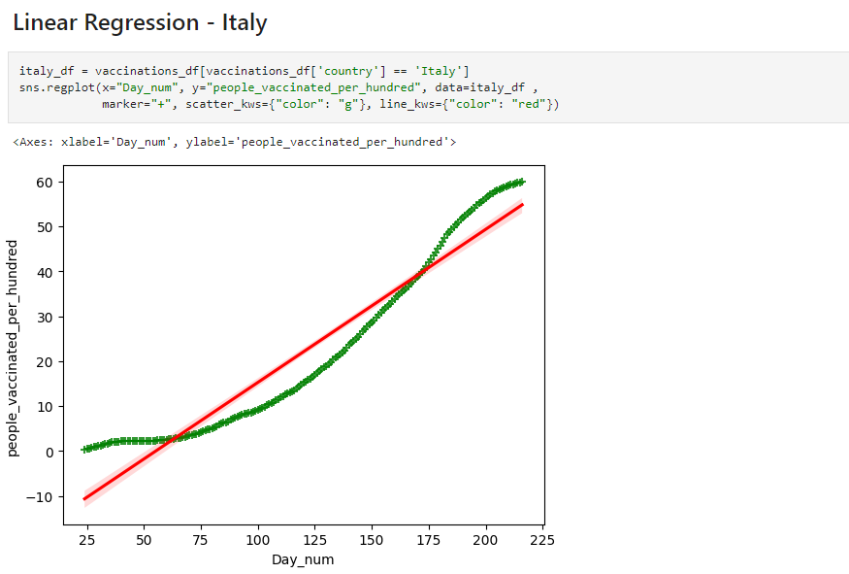

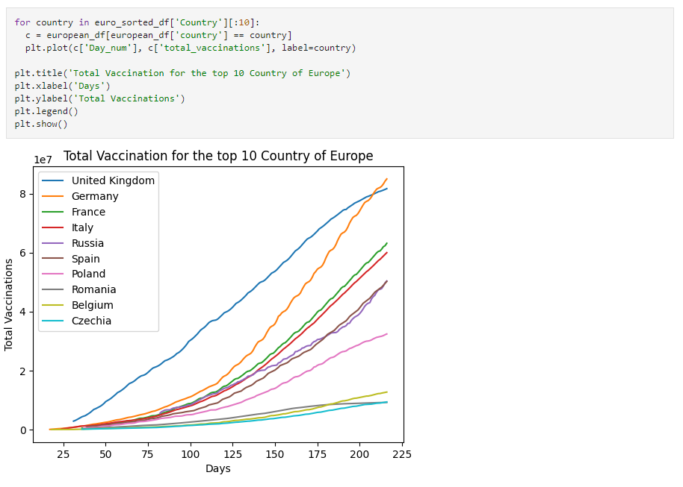

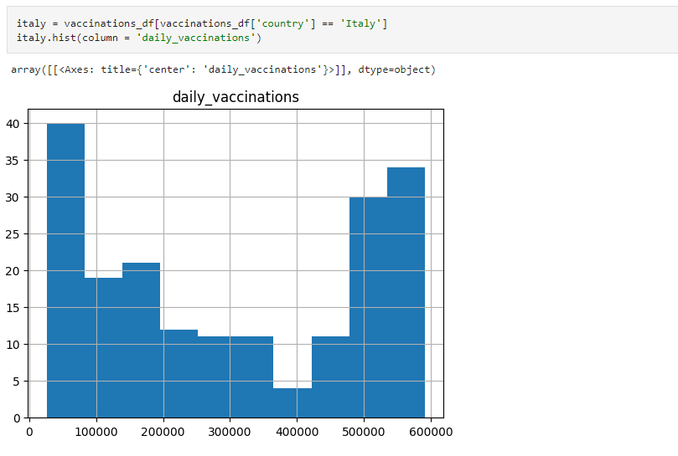

**CONCLUSION:**

In conclusion, an in-depth analysis of COVID-19 vaccine data offers invaluable insights to guide policymakers and health organizations in optimizing vaccine deployment strategies. It enables data-driven decisions that enhance vaccine access, safety, and efficacy, ultimately contributing to the global effort to control the pandemic. This analysis is a dynamic process, continually updated as new data and insights emerge to support effective public health responses.

In sum, the in-depth analysis of COVID-19 vaccine data is an indispensable tool for policymakers and health organizations in their mission to control and combat the pandemic. The insights gained from this analysis enable a more strategic, data-informed approach to vaccination campaigns, ensuring that vaccines are deployed effectively, equitably, and with a keen focus on safety and public trust. This work represents a dynamic and evolving effort, reflecting the commitment of healthcare professionals, researchers, and policymakers to safeguard public health.